Blockchain Experiment 2

Name: Atharva Lotankar
Class: D20C R.No.: 20
Date: 19 / 08 / 2026

Aim: Create a Blockchain using Python

Theory:
Blockchain is a distributed and immutable ledger that records data in a sequence of linked blocks. Each block contains a timestamp, proof (from Proof-of-Work), and the hash of the previous block, ensuring integrity and security.
In this program:
- Block Creation – A block is generated using create_block() with a proof and previous hash.
- Proof-of-Work (PoW) – Implemented to mine a block by solving a cryptographic puzzle (finding a hash with leading zeros).
- Hashing – SHA-256 algorithm ensures data immutability.
- Validation – is_chain_valid() checks that every block correctly references the previous hash and satisfies PoW conditions.
- Flask Web API – Routes /mine_block, /get_chain, and /is_valid allow mining, fetching the chain, and verifying blockchain integrity through a browser or API client.
This program runs on a local server and simulates mining a blockchain without a network of nodes, making it an ideal introductory model to understand blockchain basics.

Program #1: Python program using Google Colab for Interactive Blockchain Logic & Demo Execution

Program:
import datetime
import hashlib
import json

class Blockchain:
def __init__(self):
self.chain = []
self.transactions = []
# Create Genesis Block (Block 1)
self.create_block(proof=1, previous_hash='0')

def create_block(self, proof, previous_hash):
"""
Creates a new block in the blockchain and attaches current transactions.
Clears pending transactions list afterward.
"""
block = {
'index': len(self.chain) + 1,
'timestamp': str(datetime.datetime.now()),
'proof': proof,
'previous_hash': previous_hash,
'transactions': self.transactions
}
self.chain.append(block)
# Empty transaction list after mining
self.transactions = []
return block

def get_previous_block(self):
return self.chain[-1]

def create_transaction(self, sender, receiver, amount):
"""
Adds transaction to pending list and returns target block index.
"""
self.transactions.append({
'sender': sender,
'receiver': receiver,
'amount': amount
})
return len(self.chain) + 1

def proof_of_work(self, previous_proof):
"""
Cryptographic puzzle: searches for a golden nonce where
SHA-256 output starts with '000' leading zeros.
"""
new_proof = 1
check_proof = False

while check_proof is False:
hash_operation = hashlib.sha256(
str(new_proof**2 - previous_proof**2).encode()
).hexdigest()

if hash_operation[:3] == '000':
check_proof = True
else:
new_proof += 1

return new_proof

def hash(self, block):
encoded_block = json.dumps(block, sort_keys=True).encode()
return hashlib.sha256(encoded_block).hexdigest()

def is_chain_valid(self, chain):
previous_block = chain[0]
block_index = 1

while block_index < len(chain):
block = chain[block_index]

# 1. Verify previous hash matching
if block['previous_hash'] != self.hash(previous_block):
return False

# 2. Verify Proof of Work target (3 leading zeros)
previous_proof = previous_block['proof']
proof = block['proof']
hash_operation = hashlib.sha256(
str(proof**2 - previous_proof**2).encode()
).hexdigest()

if hash_operation[:3] != '000':
return False

previous_block = block
block_index += 1

return True
# Instantiate Blockchain
blockchain = Blockchain()

def mine_block():
# Mine ONLY if transaction list is not empty
if not blockchain.transactions:
return {'message': 'No transactions to mine. Add some transactions first!'}

previous_block = blockchain.get_previous_block()
previous_proof = previous_block['proof']
proof = blockchain.proof_of_work(previous_proof)
previous_hash = blockchain.hash(previous_block)

block = blockchain.create_block(proof, previous_hash)

return {
'message': 'Congratulations, you just mined a block!',
'index': block['index'],
'timestamp': block['timestamp'],
'proof': block['proof'],
'previous_hash': block['previous_hash'],
'transactions': block['transactions']
}

def add_transaction(sender=None, receiver=None, amount=None):
if sender is None:
sender = input("Enter sender: ")
receiver = input("Enter receiver: ")
amount = float(input("Enter amount: "))

index = blockchain.create_transaction(sender, receiver, amount)
return {'message': f'Transaction will be added to Block {index}'}

def get_chain():
return {
'chain': blockchain.chain,
'length': len(blockchain.chain)
}

def is_valid():
valid = blockchain.is_chain_valid(blockchain.chain)
if valid:
return {'message': 'All good. The Blockchain is valid.'}
return {'message': 'Houston, we have a problem. The Blockchain is not valid.'}
# Block 1 is already auto-generated as Genesis Block

# Add Transaction & Mine Block 2
print(add_transaction(sender="Atharva", receiver="Manu", amount=100.0))
print(json.dumps(mine_block(), indent=2))
print("-" * 50)

# Add Transaction & Mine Block 3
print(add_transaction(sender="Manu", receiver="Ronit", amount=45.5))
print(json.dumps(mine_block(), indent=2))
print("-" * 50)

# Add Transaction & Mine Block 4
print(add_transaction(sender="Ronit", receiver="Me", amount=12.0))
print(json.dumps(mine_block(), indent=2))
print("--- FULL BLOCKCHAIN DETAILS ---")
print(json.dumps(get_chain(), indent=2))

print("\n--- VALIDITY CHECK ---")
print(json.dumps(is_valid(), indent=2))
print("Functions Menu:")
print("===============")
print("1. Mine a block")
print("2. Display the chain")
print("3. Check the validity of the chain")
print("4. Add transaction to the blockchain")

try:
choice = int(input("Enter your choice: "))
if choice == 1:
print(json.dumps(mine_block(), indent=2))
elif choice == 2:
print(json.dumps(get_chain(), indent=2))
elif choice == 3:
print(json.dumps(is_valid(), indent=2))
elif choice == 4:
print(json.dumps(add_transaction(), indent=2))
else:
print("Invalid choice")
except ValueError:
print("Please enter a valid numeric choice.")

Output:
Functions Menu:
===============
1. Mine a block
2. Display the chain
3. Check the validity of the chain
4. Add transaction to the blockchain
Enter your choice: 2
{
"chain": [
{
"index": 1,
"timestamp": "2026-08-19 06:58:29.364931",
"proof": 1,
"previous_hash": "0",
"transactions": []
},
{
"index": 2,
"timestamp": "2026-08-19 06:58:32.805839",
"proof": 533,
"previous_hash": "c2103ac5877977c82bd3c3581d40f8b987acc9bda75099214d0e9eef53a41dc3",
"transactions": [
{
"sender": "Atharva",
"receiver": "Manu",
"amount": 100.0
}
]
},
{
"index": 3,
"timestamp": "2026-08-19 06:58:32.818131",
"proof": 11028,
"previous_hash": "7309039886650294b6ca39efea642fb8cb4c70503df9f92692e3a1b670a6d93f",
"transactions": [
{
"sender": "Manu",
"receiver": "Ronit",
"amount": 45.5
}
]
},
{
"index": 4,
"timestamp": "2026-08-19 06:58:32.818917",
"proof": 396,
"previous_hash": "e75a3d7bca038a4f82229af1882c3febe4278c7da12cd48d7226720a779f5b93",
"transactions": [
{
"sender": "Ronit",
"receiver": "Me",
"amount": 12.0
}
]
},
{
"index": 5,
"timestamp": "2026-08-19 07:00:13.289880",
"proof": 1430,
"previous_hash": "21d6a921f991a12c2a765776eb069cb3a1a2f9e4c08499293faad9f6728173cc",
"transactions": [
{
"sender": "Me",
"receiver": "Saniya",
"amount": 489.0
}
]
}
],
"length": 5
}

Program #2: Python Program using Flask via VS Code: Flask REST API Blockchain Server

Program:
import datetime
import hashlib
import json
from flask import Flask, jsonify, request

class Blockchain:

def __init__(self):
self.chain = []
self.transactions = []
# Create Genesis Block
self.create_block(proof=1, previous_hash='0')

def create_block(self, proof, previous_hash):
block = {
'index': len(self.chain) + 1,
'timestamp': str(datetime.datetime.now()),
'proof': proof,
'previous_hash': previous_hash,
'transactions': self.transactions
}
self.transactions = [] # Clear transaction pool after mining
self.chain.append(block)
return block

def get_previous_block(self):
return self.chain[-1]

def create_transaction(self, sender, receiver, amount):
self.transactions.append({
'sender': sender,
'receiver': receiver,
'amount': amount
})
return len(self.chain) + 1

def proof_of_work(self, previous_proof):
new_proof = 1
check_proof = False

while check_proof is False:
hash_operation = hashlib.sha256(
str(new_proof**2 - previous_proof**2).encode()
).hexdigest()

if hash_operation[:3] == '000':
check_proof = True
else:
new_proof += 1

return new_proof

def hash(self, block):
encoded_block = json.dumps(block, sort_keys=True).encode()
return hashlib.sha256(encoded_block).hexdigest()

def is_chain_valid(self, chain):
previous_block = chain[0]
block_index = 1

while block_index < len(chain):
block = chain[block_index]

if block['previous_hash'] != self.hash(previous_block):
return False

previous_proof = previous_block['proof']
proof = block['proof']
hash_operation = hashlib.sha256(
str(proof**2 - previous_proof**2).encode()
).hexdigest()

if hash_operation[:3] != '000':
return False

previous_block = block
block_index += 1

return True

# ------------------------------------------------------------
# Flask API Routes
# ------------------------------------------------------------
app = Flask(__name__)
blockchain = Blockchain()

@app.route('/add_transaction', methods=['POST'])
def add_transaction():
json_data = request.get_json()
transaction_keys = ['sender', 'receiver', 'amount']
if not all(key in json_data for key in transaction_keys):
return 'Missing transaction fields', 400

index = blockchain.create_transaction(
json_data['sender'],
json_data['receiver'],
json_data['amount']
)
response = {'message': f'Transaction will be added to Block {index}'}
return jsonify(response), 201

@app.route('/mine_block', methods=['GET'])
def mine_block():
if not blockchain.transactions:
return jsonify({'message': 'No pending transactions to mine!'}), 400

previous_block = blockchain.get_previous_block()
previous_proof = previous_block['proof']
proof = blockchain.proof_of_work(previous_proof)
previous_hash = blockchain.hash(previous_block)

block = blockchain.create_block(proof, previous_hash)

response = {
'message': 'Block mined successfully!',
'index': block['index'],
'timestamp': block['timestamp'],
'proof': block['proof'],
'previous_hash': block['previous_hash'],
'transactions': block['transactions']
}
return jsonify(response), 200

@app.route('/get_chain', methods=['GET'])
def get_chain():
response = {
'chain': blockchain.chain,
'length': len(blockchain.chain)
}
return jsonify(response), 200

@app.route('/is_valid', methods=['GET'])
def is_valid():
valid = blockchain.is_chain_valid(blockchain.chain)
if valid:
response = {'message': 'The Blockchain is valid.'}
else:
response = {'message': 'The Blockchain is invalid.'}
return jsonify(response), 200

if __name__ == '__main__':
app.run(host='0.0.0.0', port=5000)

Output:
Postman Testing
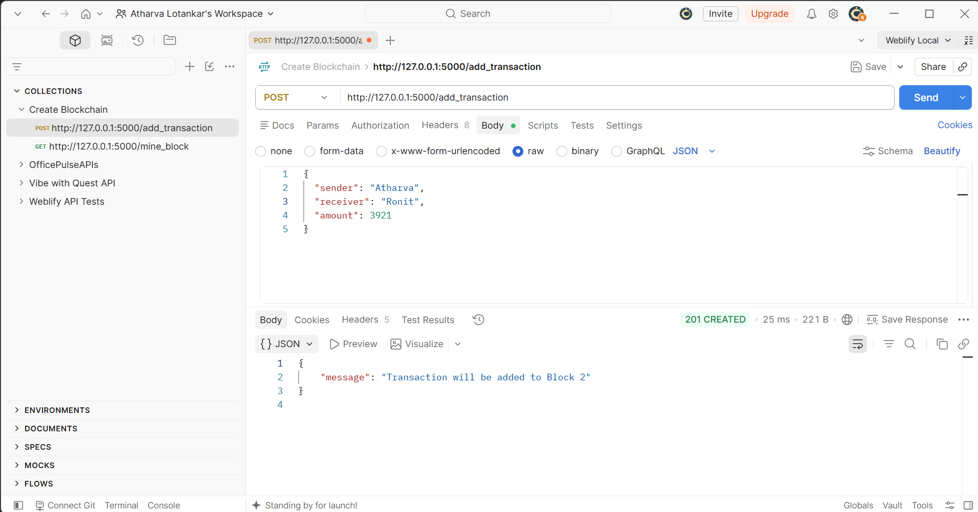
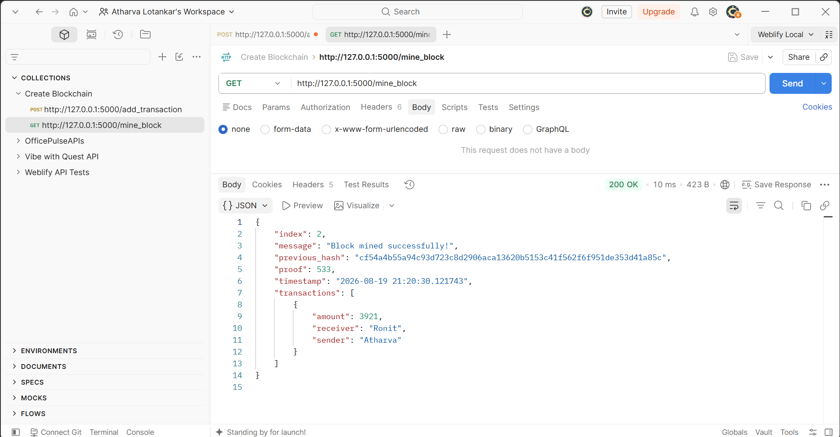

VScode Flask Running
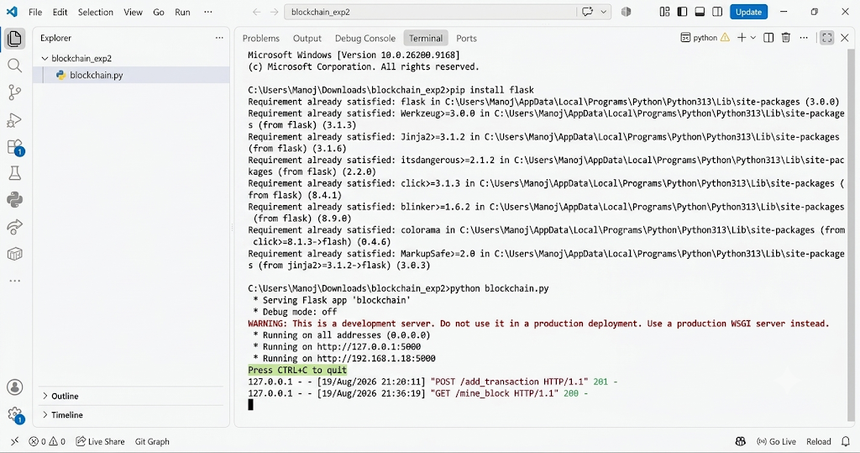

Conclusion:
We successfully created a basic blockchain using Python and Flask that supports block mining, chain retrieval, and validity checks. Proof-of-Work ensures security by making block creation computationally intensive, while cryptographic hashing guarantees immutability. The implementation demonstrates core blockchain principles—decentralization, immutability, and consensus—in a simplified environment, providing a strong foundation for building more advanced blockchain systems.

